John Michael Go
Career Entry Level Java Programming
Date: Jan. 22, 2013

DAY 8

Program Name: Array3

Objective: Program that determines the smallest element of an array.

Algorithm:

1. Program outputs the smallest element of an array.

Flowchart:

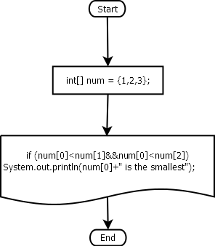

Pseudocode:

public class Array3 {

public static void main(String[] args) {
int[] num = {1,2,3};
if (num[0]<num[1]&&num[0]<num[2])
System.out.println(num[0]+" is the smallest");

}

}

Screenshots:

